**PRACTICAL FILE**

**BE (CSE) 7th Semester**

|  |
| --- |
| **Software Project Management**  **July 2023 – December 2023** |
| **Submitted By**  **Rohit Kumar Singh**  **Roll Number: UE203093** |
| **Submitted To**  **Ms. Bharti**  **Faculty, Computer Science and Engineering** |
| **Computer Science and Engineering**  **University Institute of Engineering and Technology**  **Panjab University, Chandigarh – 160014, INDIA**  **2023** |

**INDEX**

|  |  |  |  |
| --- | --- | --- | --- |
| **S. No.** | **Name of Practical/Program** | **Page No.s** | **Remarks** |
| 1 | Cost/Benefit analysis   * Implement cost-benefit analysis using any programming language * Perform cost-benefit analysis using any Project management tool | 3 |  |
| 2 |  |  |  |
| 3 |  |  |  |
| 4 |  |  |  |
| 5 |  |  |  |
| 6 |  |  |  |
| 7 |  |  |  |
| 8 |  |  |  |
| 9 |  |  |  |

**Practical 1**

**Aim:** Cost/Benefit analysis

1. Implement cost-benefit analysis using any programming language
2. Perform cost-benefit analysis using any Project management tool

**Theory** :

A cost-benefit analysis (CBA) is a process that’s used to estimate the costs and benefits of projects or investments to determine their profitability for an organization. A CBA is a versatile method that’s often used for business administration, project management and public policy decisions. An effective CBA evaluates the following costs and benefits:

Costs

* Direct costs
* Indirect costs
* Intangible costs
* Opportunity costs
* Costs of potential risks

Benefits

* Direct
* Indirect
* Total benefits
* Net benefits

These costs and benefits are then assigned a monetary value and used to determine the cost-benefit ratio. However, a cost-benefit analysis might also involve other calculations such as return on investment (ROI), internal rate of return (IRR), net present value (NPV) and the payback period (PBP).

## Cost-Benefit Ratio :

The cost-benefit ratio, or benefit-cost ratio, is the mathematical relation between the costs and financial benefits of a project. The cost-benefit ratio compares the present value of the estimated costs and benefits of a project or investment.

Cost-Benefit Ratio= Sum of Present Value Benefits / Sum of Present Value Costs

Here’s how you should interpret the result of the cost-benefit ratio formula.

* If the result is less than 1: The benefit-cost ratio is negative, therefore the project isn’t a good investment as its expected costs exceed the benefits.
* If the result is greater than 1: The cost-benefit ratio is positive, which means the project will generate financial benefits for the organization and it’s a good investment. The larger the number, the most benefits it’ll generate.

### Present Value Formula :

The present value of a project’s benefits and costs is calculated with the present value formula (PV).

PV = FV/(1+r)^n

* FV = Future value
* r = Rate of return
* n = Number of periods

**1. Implement cost-benefit analysis using any programming language**

**Code :**

#include<bits/stdc++.h>

using namespace std;

float NPVCalculator(int years, int costs[], int benefits[], int discountRate[]){

float npv = 0.0;

*for*(int i=0; i<years; i++){

float rateFactor = pow(1+(float(discountRate[i])/100.0), (i));

float rate = 1.0/(rateFactor);

cout << "Rate Factor: " << rateFactor << "\t";

cout << "Rate: " << rate << "\t";

npv += ( benefits[i]-costs[i])*rate;

cout << "NPV: " << npv << endl;

}

*return* npv;

}

int main(){

cout << "Enter Years\n";

int years;

cin >> years;

years++;

cout << "Enter cost for " << years << " years\n";

int costs[years+1];

*for*(int i=0; i<years; i++){

cin >> costs[i];

}

cout << "Enter benefits for " << years << " years\n";

int benefits[years+1];

*for*(int i=0; i<years; i++){

cin>>benefits[i];

}

cout << "Enter discount rates " << years << " years\n";

int discountRate[years+1];

*for*(int i=0; i<years; i++){

cin >> discountRate[i];

}

float npv = NPVCalculator(years, costs, benefits, discountRate);

cout << "Net Profit Value = "<< npv << endl;

*return* 0;

}

**Output :**

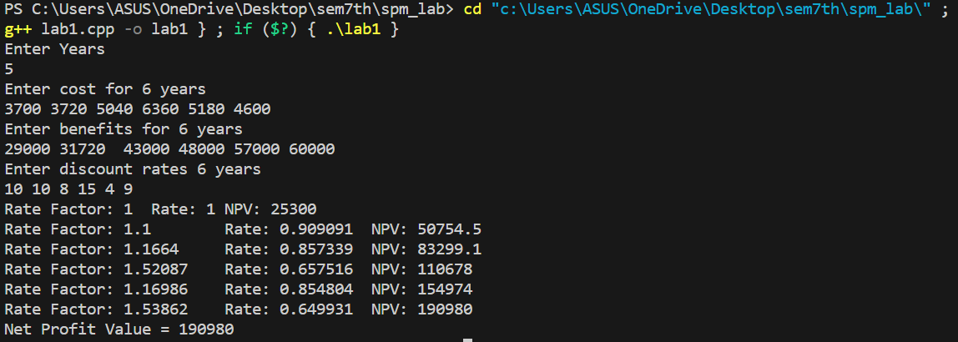

**2. Perform cost-benefit analysis using any Project management tool**

Formulas Used -

—----> rateFactor = (1+(float(discountRate[i])/100.0)^i

—----> rate = 1.0/(rateFactor)

—----> npv += ( benefits[i]-costs[i])*rate

